
Saleel Ajit Shetye
307 J.M. Villa, Near CKP Hall,
Dombivli East, 421201
Cell: 9819369621, Email: saleelshetye84@gmail.com

Objective
To work with an organization where my work experience and education can be productively utilized as a software engineer in my chosen area of expertise.
Education
University of Mumbai, Mumbai, India Sep ’02 – Nov ‘07
Bachelor of Engineering, Electronics and Telecommunication GPA – 3.00/4.00
Summary
- Around four years of experience in software application development.
- Participated in all aspects of Software Development Life Cycle.
- Able to handle task independently with minimal supervision.
- Worked with a small aggressive startup, mid size firm and a fully fledged enterprise positioned globally.
- Worked with functional domains like digital signage, airline revenue accounting and BFS.
- Exposure to multi ethnic corporate environments in India and the United States.
- Excellent client interaction skills.
- Comfortable working with huge code bases and product setups.

Technical Skills
- Programming Languages:
* Proficient: C++, PLSQL, Bash/Shell scripting, STL, Data structures,
* Intermediate: C, Python, Pro*C, Interprocess Communication( C/Linux), Multithreading.
- Operating Systems: Linux, UNIX, Windows 98/2000/XP/Vista.
- Tools: Eclipse IDE, gdb, gprof, valgrind, SQL Navigator, PLSQL-Developer, TOAD, SQL Loader, SVN, IBM Rational Rose Architect, Visual Studio 2008
- Database packages: Oracle 10g Release 2 (Administration, Backup and Recovery), DB import/export utilities.
- Application Servers: Jboss
- Web Servers: Apache Web server, Apache Tomcat

Work Experience
Technical Lead, iGATE Corporation, Mumbai, India Mar ’12 – Till date 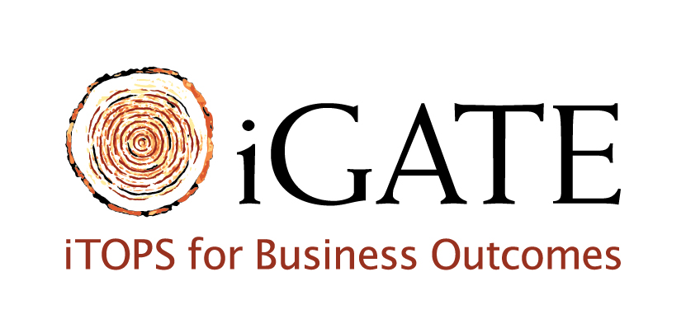
- Develop solutions and proposed changes for the client.
- Working in the Banking Financial Services (BFS) domain.
- Working on Linux platform using C++ as the programming language.
Project : GE Capital Jan ’13 – Till Date 
Client: General Electric Inc., USA
GECRB : GE Capital's Retail Finance business provides financing services, enabling consumers to make purchases through a range of flexible financial products and across a broad network of businesses and retailers. They offer private label credit card programs, promotional and installment lending, bankcards and financial services for consumers through dealers; national, regional and independent retailers.
Platform: C, C++, Linux, Unix, Shell Scripts.

Roles and Responsibilities:
1) Migration of the legacy application from Unix to Linux platform.
2) Resolving all the technical issues related to the project.
3) Modifying shell scripts and makefiles for any changes related to machine architecture and build libraries.
4) Enhancing the codebase for any security remediation and ensuring the prevention of any buffer overflows,
Memory leaks etc.
5) Code changes which need to be done while porting the application from 32 bit Solaris machine to 64 bit
Linux machine.

Project : Experian NCAC (National Consumer Assistance Center) May ’12 – Dec ’12 
Client: Experian Consumer Information Services Inc., Chile South America.
Experian® is a global leader in providing information, analytical tools and marketing services to organizations and consumers to help manage the risk and reward of commercial and financial decisions. Experian is a global leader in consumer and business credit reporting and marketing services.

Platform: Visual Studio 2008, C++
Team size: 8
Software Methodology: Agile (Scrum).
Roles and Responsibilities:
1) Implementing the enhancements for the NCAC product.
2) Upgrading the product for code security considerations.
3) Creating the design document for the high level design document or System requirement document.
4) Supporting the QA team in the UAT phase.

Software Development Intern, Zignage LLC., Brooklyn, New York Nov ’10 - Jan ’11, 
Jun ’11 – Sep’11
- Design, development, implementation and support of Audio/Video recorder project at the NYU School of law.
- Hardware/software interfacing/trouble shooting issues with the equipment used for the project.
- The platform used was Linux and the programming languages were C++, Python and shell scripting.

Project : Audio Video Recorder
Client: New York University School of Law, New York, USA.
Platform: Linux, C++, Python.
Team size: 10
Software Methodology: Iterative Model.
Roles and Responsibilities:
1) Requirements understanding and analysis.
2) Coding the requirements as per the specifications

Sr Programmer Analyst at Accelya Kale Solutions Ltd., Mumbai, India Apr ’10 - July ’10 
- Managed the entire build configuration for the product REVERATM and supporting the Build Manager.
- Lead a team of 3 members towards delivering all implementation related activities within the scheduled delivery timelines. Performed the causal analysis on the completion of every Product Release.

Programmer Analyst at Accelya Kale Solutions Ltd., Mumbai, India Nov ’07 - Mar ‘10
- Handled issues related to the product REVERATM, a sophisticated passenger revenue accounting software.
- Support the Quality Analyst Team in the development, Pre-Release and Post-Release period.
- Prepared the product setups (Application server, Database and Linux platform) for REVERATM.
- Responsible for resolving client calls during the UAT phase of the project and delegating calls to the module teams.
- Responsible for resolving calls from the client site in the Post Release period till the warranty period.
- Developed various customizations from clients (Air India, Qatar Airways, British Midland Airways, Bangkok Airways etc) using PLSQL, Pro*C, C++, JAVA.

Project Intern at Reliance Infocomm, DAKC, Mumbai, India Jan ’06 - Apr ’06 
- SS7 Surveillance and design and development of a multi-protocol hex decoder for IS-41 message monitoring.
- Technologies used were C++, Windows.

Coursework
Polytechnic Institute of New York University, New York, NY Fall ’10, Spring ’10, Fall ‘11
GPA – 2.87/4.00
Software engineering 1,
Design and analysis of algorithms 1,
Information security and privacy.
Introduction to operating systems,
Biometrics,
Data structures,
Programming languages,
Principles of database systems,
Foundations of computer science.

Academic Projects
Polytechnic Institute of New York University, New York, NY
- Project paper presented on File systems in Linux describing the various existing file systems, Fall ‘10
and their comparative performance with respect to architecture, data retrieval capabilities and journaling capabilities.
- Enhancement carried out for the Verilog SDK for facial biometric recognition system. Fall ‘10
- Designed, created and implemented Oracle database for a commercial system. Implemented Spring ‘10
a UI on a Web browser for the users to access this database.
- Designed, created and implemented a BattleShip game as a part of Software Engineering course Fall ‘11
Lead a team of 3 members towards successful implementation.

Extra Curricular
- Won 2nd Prize in the national level technical paper presentation on MEMS technology.
- Won 2nd Prize in the inter college technical paper presentation (MEMS and next generation displays).
- Won the “The Rising Star Award” for being the best performer in the month of May ’10 at Kale Consultants Ltd. for implementing the entire end to end product setup at the client site with minimum defects at FLYBE.com.
- Passed National Stock Exchange’s Exam in the Financial Markets Derivatives Dealer’s Module and Securities Markets Module.

